|  |
| --- |
| Name: Thuduwe Pehesara |
| Student Reference Number:10898586 |



|  |  |  |
| --- | --- | --- |
| Module Code: PUSL2021 | Module Name: Computing Group Project | |
| Coursework Title: Tuition Class Management System | | |
| Deadline Date:25/10/2023 | | Member of staff responsible for coursework: Mr. Pramudhya Thilakarathne |
| Programme: Computing Group Project | | |
| Please note that University Academic Regulations are available under Rules and Regulations on the University website [www.plymouth.ac.uk/studenthandbook](http://www.plymouth.ac.uk/studenthandbook). | | |
| Group work: please list all names of all participants formally associated with this work and state whether the work was undertaken alone or as part of a team. Please note you may be required to identify individual responsibility for component parts.  Group 82  10898586 - Thuduwe Pehesara  10898418 - Hetti Avishka  10898708 - Ramboda Wijerathna  10899688 - Wickramaarachchige Sayuranga  10899581 - Dushan Karunathilaka  ***We confirm that we have read and understood the Plymouth University regulations relating to Assessment Offences and that we are aware of the possible penalties for any breach of these regulations. We confirm that this is the independent work of the group.***  Signed on behalf of the group: | | |
| Individual assignment: ***I confirm that I have read and understood the Plymouth University regulations relating to Assessment Offences and that I am aware of the possible penalties for any breach of these regulations. I confirm that this is my own independent work.***  Signed : | | |
| Use of translation software: failure to declare that translation software or a similar writing aid has been used will be treated as an assessment offence.  I *have used/not used translation software.  If used, please state name of software………………………………………………………………… | | |
| **Overall mark _____% Assessors Initials ______ Date_________** | | |

*Please delete as appropriateSci/ps/d:/students/cwkfrontcover/2013/14

**Tuition Class Management System**

**Computing Group Project**

PUSL 2021

Plymouth Badge 11

(Group 82)

10898586 - Thuduwe Pehesara

10898418 - Hetti Avishka

10898708 - Ramboda Wijerathna

10899688 - Wickramaarachchige Sayuranga

10899581 - Dushan Karunathilaka

Contents

Overview / Introduction 4

Tuition Class Management System 4

Objectives 5

Target Users 6

Application Features and Description 7

Cost Estimation 8

Time Frame (Gantt Chart) 9

Contribution 11

# Overview / Introduction

## Tuition Class Management System

We present to you a project proposal aimed at ushering in a new era of tuition management where education in Sri Lanka embraces modern technology and innovation. Our team introduces a software that will redefine the field of assisted education.

Our team's primary objective is to add new technology to traditional tuition institutions. We expect this project to empower tuition institutions in Sri Lanka to operate with high accuracy, unmatched efficiency and remarkable speed. The project will simplify administrative processes for teachers and institutions while ensuring a seamless process for every student.

The origins of this project lie in our experiences as former tuition students. Let's understand things like waiting in long queues for manual attendance marking, tuition fee errors and sudden class cancellations. These experiences have motivated us to make a difference in students and institutions.

The first step in our team's project is to mark attendance. This happens automatically. We use a smart card for this. This system allows for quick and accurate marking of student attendance, replacing the manual processes of marking class cards and ensuring that students are no longer burdened in long queues.

Here we create a profile related to the student in the software. All the student's details and parents' details are included in that profile.

It is related to the student's smart card. When the card is scanned, the administrator will be able to know all the details of the student.

This software introduces a comprehensive tuition fee management system. This software allows you to accept payments and track payment history. Administrators will no longer have to rely on paper records, streamlining payments across the entire financial side of tuition management.

Apart from this, parents can know about their child's arrival, departure and class fee payment from home without visiting the institute.

# Objectives

This project aims to achieve the following objectives:

Students

* To develop a mobile application for the students to mark their attendance and departure.

Parents

* Develop this application to send a message to the parent after the monthly payment furthermore a message was also sent to a parent if the payment was not paid at end of the month.

Institute admin

* With this application, when the card is punched, the admin can get all the details of the students.
* Also, Admin can calculate the total attendance of the students at the end of the class.
* Admins can calculate their profit at the end of the month.

# Target Users

* Students
* teachers
* Parents
* Institute admin

# Application Features and Description

Smart card

|  |  |
| --- | --- |
| **Features** | **Description** |
| To mark attendance | Students should punch the card when entering to the class. |
|  | When student punched the card, automatic massage sent to their parents with class fees details, time of arrival and departure of the class and special information about the class |

Mobile and Desktop Application

|  |  |
| --- | --- |
| **Features** | **Description** |
| Student profile | Student details  Students’ parent’s details  What Classes he/she joined. |
| Teacher profile | Teachers’ details |
| Payment gateway | Profit report for the admin panel.  Students can pay via the application.  Students and parents can see payment details. |
| Attendance report | Admin panel can see student attendance sheets to make decisions. |
| Timetable | Teachers and students can see the times for their classes.  Admin panel can arrange their class via seen this timetable.  Parents also can their students class time.  If there are no class all the users can see it. |
| Alerts and Notifications | If there is a special alert, all the users can reach easily. |

# Cost Estimation

|  |  |
| --- | --- |
|  | **Estimated Cost (LKR)** |
| Smart card | Rs 300.00*10 = Rs 3,000.00 |
| NFC reader | Rs 15,000.00 |
| Bar code reader | Rs 10,000.00 |
| Server | Rs 10,000.00 |
| **Total** | Rs 38,000.00 |

# Time Frame (Gantt Chart)

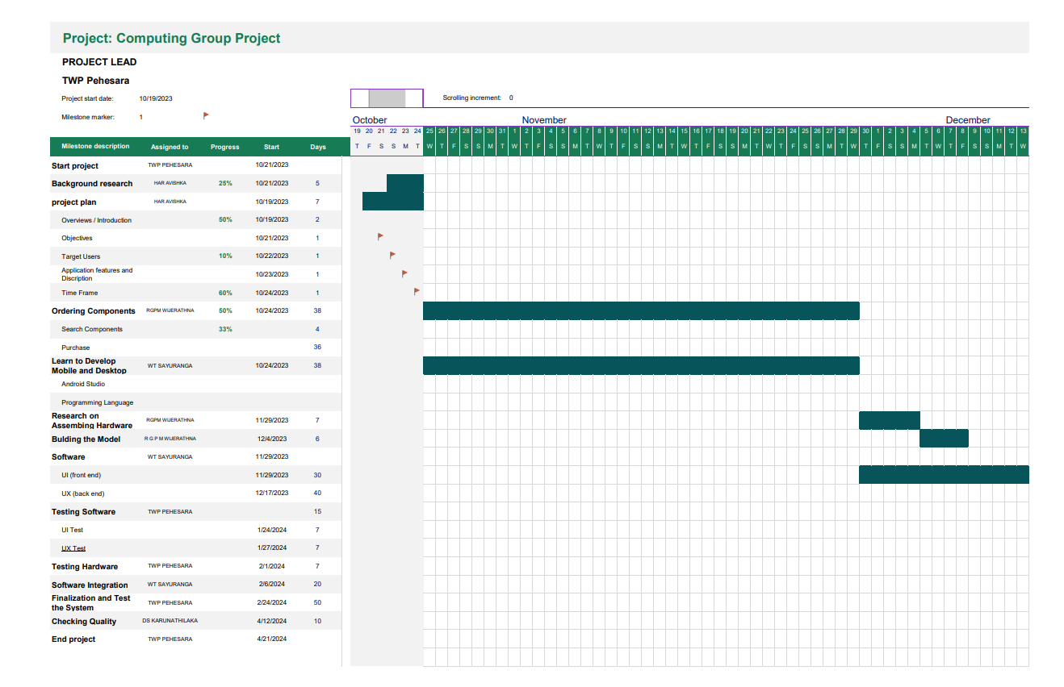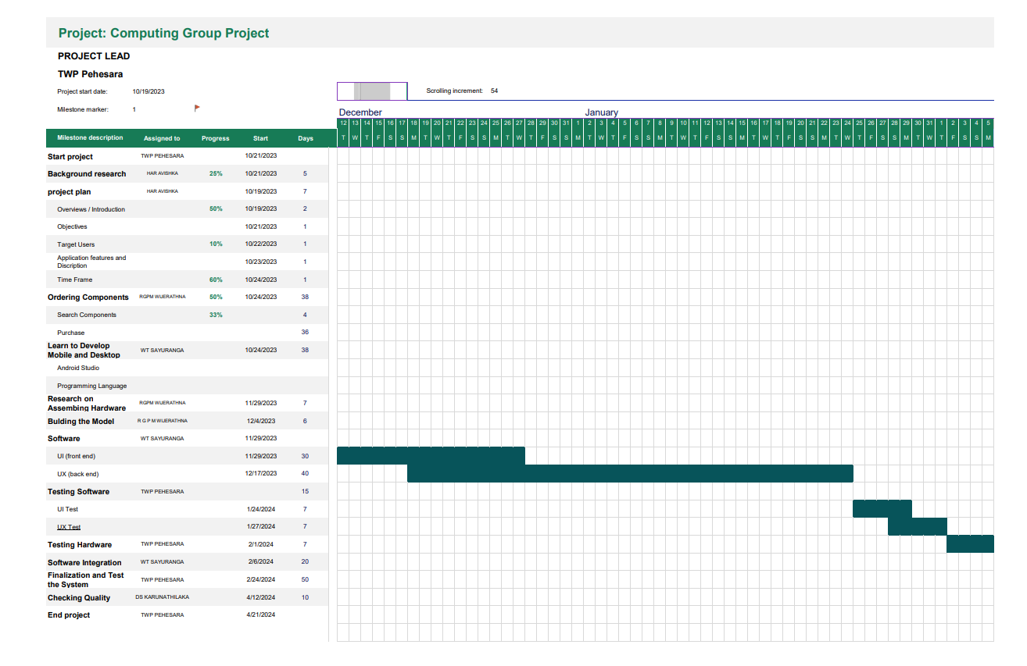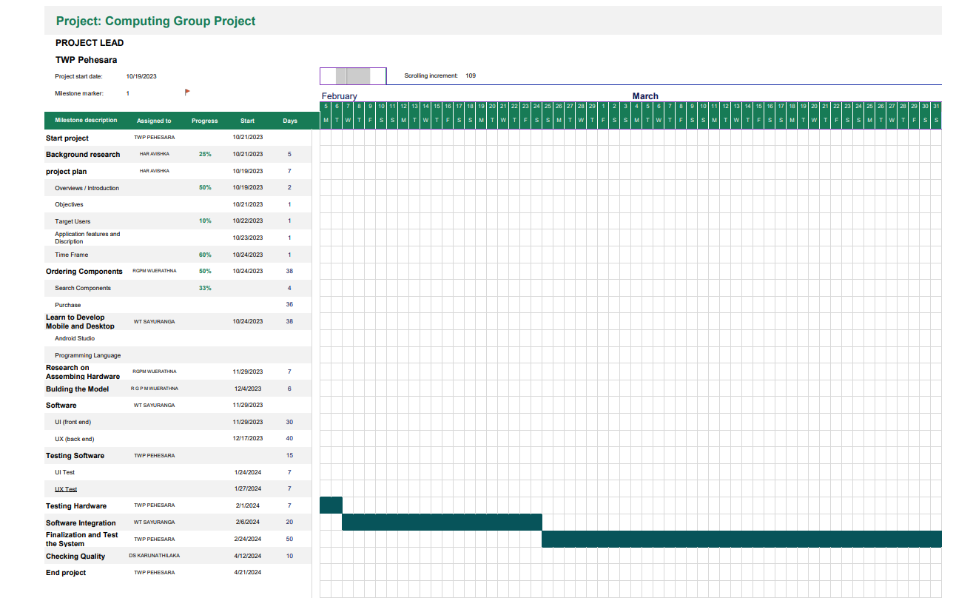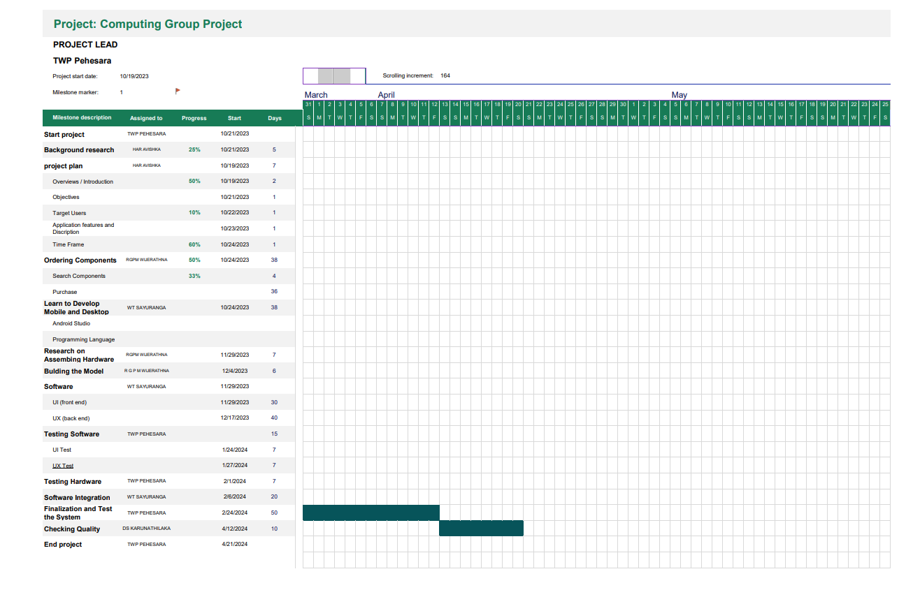

# 

# Contribution

|  |  |  |  |  |  |
| --- | --- | --- | --- | --- | --- |
| **NSBM**  **ID** | **PLYMOUTH ID** | **NSBM Name** | **PLYMOUTH Name** | **Leaders** | **Contribution** |
| 25427 | 10898586 | TWP Pehesara | Thuduwe Pehesara | Project Leader  Testing and Maintenance Leader | * Gantt Chart * Application Features and Description * Contribution |
| 25551 | 10898418 | HAR Avishka | Hetti Avishka | Planning Leader | * Gantt Chart |
| 25922 | 10898708 | GPM Wijerathna | Ramboda Wijerathna | Technical  Leader | * Cost Estimation |
| 25535 | 10899688 | WT Sayuranga | Wickramaarachchige SSayuranga | Programming  Leader | * Introduction |
| 27227 | 10899581 | DS Karunathilaka | Dushan Karunathilaka | Quality Leader | * Objectives * Target Users |